YOUSTAR
Training Course
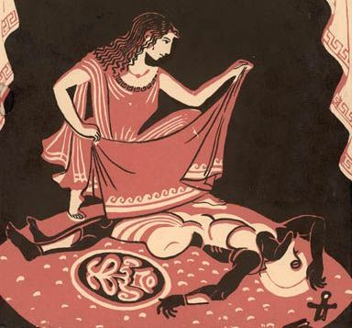

Info Pack for participants
30th March - 6th April 2022 Palermo, Italy

Powered by

CIAS LA GUILLA
www.teatroallaguilla.it

via Sant’Agata alla Guilla, 18 Palermo - Italy

CONTACT DETAILS DURING THE TRAINING COURSE:
Feel free to contact us at any time in case of emergency.
Dario Ferrante
Mobile: +39 320 413 37 64
Email:ferrante.dario@gmail.com
Valerio Strati
Mobile: +39 340 680 13 22
teatroallaguilla@gmail.com

During the whole Training Course period you can always ask information and support at:

Teatro alla Guilla
Via Sant’Agata alla Guilla, 18 Palermo, Italy

YOUSTAR

YOuth workers USing Theatre Against Radicalisation
Training Course
YO.US.T.A.R. is a 5-day Training Course (TC), under the Erasmus+ programme that will be organised and hosted by CIAS LA Guilla in Palermo, Italy. A diverse group of 30 youth workers (from different ages) coming from 9 countries (Italy, Greece, Lithuania, Romania, Portugal, Slovakia, Estonia, Bulgaria and Croatia) and 9 group leaders will participate. The YO.US.T.A.R. consortium will select youth workers, (four from Greece, Italy and Portugal and three for the other country) to come to Palermo, Sicily. In total, the TC will total 30 participants from 9 EU countries. Partner countries will select youth workers from different ages or participants with interest in the arts, and participants with migrant background or living in disadvantaged areas in their countries, experiencing social, economic, educational or geographical exclusion. Participants will experience a full immersion of performing arts and non-formal sessions, five days of activities as follows:
- energisers and contact improvisation dance and theatre techniques to foster participants' sense of identity as individuals and self-consciousness;
- introduction to themes of migration, anti-discrimination, social inclusion and European awareness to help participants think about a more inclusive Europe, and to take more proactive action at their local level, developing their understanding and experience of European citizenship;
- visits to local centres working with migrant youth or young people with fewer opportunities to develop participants' knowledge of good practices to contrast radicalisation and xenophobia;
- theatre, music and dance as means of intercultural dialogue to develop participants' awareness on discrimination and exclusion through non-formal learning methods namely theatre and creativity;

- Antigone's myth to fight exclusion and xenophobia and participants' contribution to make them more aware of discrimination and exclusion through non-formal learning methods;
- Antigone's myth: final performance set up to celebrate young people's creativity through the staging of this ancient Greek drama, and disseminate the results to other young people with final performance to other youngsters and the local community.
YO.ST.A.R. project will use non-formal methods namely theatre, music and contact improvisation to carry out all the foreseen activities. Trainers will conduct sessions using collaborative art-making and creative thinking.

Accommodation and Meeting Location

Transport from the Palermo Airport to the hostel:

By bus: exit the arrival terminal and go to your right, follow the indication “Prestia e Comandè” to find the departure of the bus. Departure every 30 minutes (last departure at 24:00).
It takes 50 minutes to arrive to Palermo City centre, last stop where you have to hop off:
Piazza Giulio Cesare /Stazione Centrale). http://www.prestiaecomande.it/ Ticket price: € 6, you can purchase your ticket at the desk counter.

---Please remember that to keep all boarding passes and any kind of receipt and/or tickets---
From Palermo City to the accommodation venue:
We will pick you at the Central Station and take you to the accommodation place, which is at walking distance. Once the bus departs from the airport, please send a whatsapp message (sms) to Valerio: +39 340 680 13 22 in order to let us know at what time we have to go to pick up you.

It’s very important for us to know your arrival time in order to organise your pick up to the hostel!
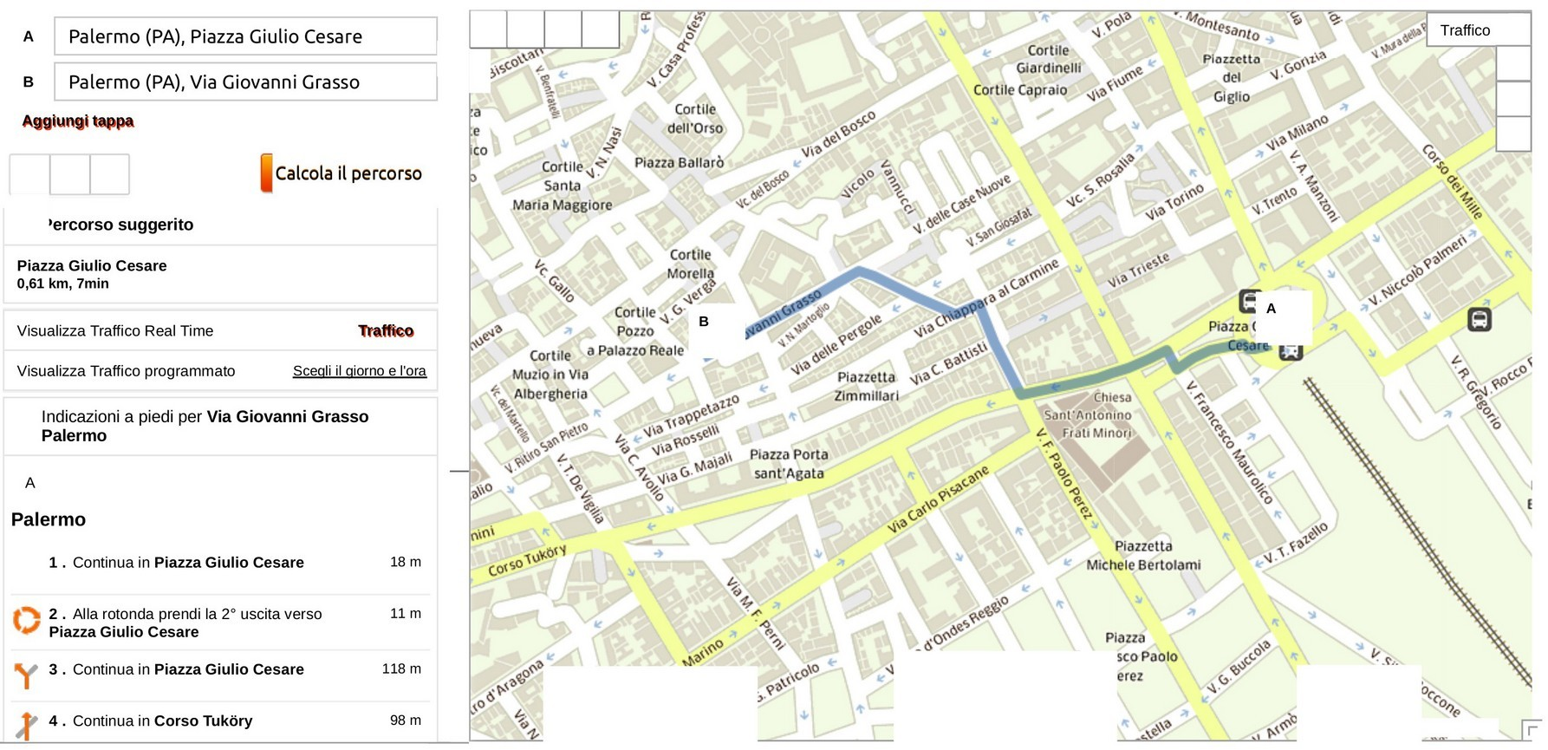

Accommodation and meeting location: Meeting Location:
The TC will take place at Convento dei Carmelitani (via Giovanni Grasso, 13) in the historical centre of Palermo, “Ballarò” market, to enjoy the city and be in contact with the local community.
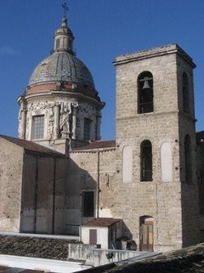
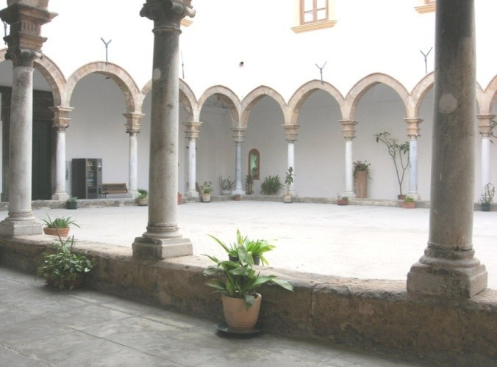

Meals
Breakfast, lunch and dinner will be provided by CIAS LA GUILLA except in case of free time at lunch.

What you have to bring with you:

You are warmly invited to bring with you:
⟶ Information materials about your organisations: brochures, posters, manuals, flyers, etc. (anything you want to share!). Please avoid Powerpoint presentations and videos because we are going to present it through the “organisations’ bazaar” method¹.

--- Info for the local coordinators: please remember to participants from your countries to bring information about their own civil society organisations!---
⟶ Prepare a short research-reflection about social, economic, geographical and other reasons behind the exclusion of youth in your country and study the Greek myth of Antygone. Please collect all the information you find and bring with you, but you will have time to prepare the presentation in the way we will propose during the TC (you don’t need to prepare a Powerpoint presentation or a paper before).

3 t-shirts: black, white and red

1 Every organisation will have a space to put their information, simulating a “bazaar”. Then participants will move around the spaces and interact among them to discover more about each one of the organisations.

Free time

- The programme schedule foresees free time every day, and we will also have a free day and free time to visit Palermo.
- During the sessions of training the participation is compulsory.
- There will be free Internet access in common spaces in the hostel, and possibility to print or photocopy materials.

FINANCIAL

What you have to know about the travel and reimbursement:
Travel costs are covered at 100% of the maximum amounts per participant (return ticket) depending on the country of origin. Usually is € 275 for most of the participating countries.
In order to get your reimbursement, please pay attention to the following procedure.
First of all, keep all the tickets you get to prove your expenses (bus tickets, train tickets, electronic flight ticket, travel agency reservations, etc.).
Second: keep all your flight boarding passes (outward and return).

---We cannot reimburse you if we do not receive the details and proofs of your expenses. ---

During the TC we will ask you to provide printed copies of:

all original tickets and receipts with the price (electronic boarding passes without the price cannot be considered)
  - outward boarding pass

photocopy of your ID card or Passport.

---Please bring it directly with you in Convento dei Carmelitani---

Once CIAS LA GUILLA has all originals, the Financial Department will analyse the documents and do the bank transfer of the travel expenses up to your country allowance. If you have spent less than the maximum amount allowed by country, we will reimburse you 100% of your actual travel costs. The bank transfer will be done after the TC, once we have received the return flight boarding passes.

TO FIND YOUR WAY IN PALERMO!

Banks
ATMs are easily available. There are exchange offices at the airport (8am to 7pm Monday to Saturday) and at the train station (8am to 8pm). Monthly accounting rate of the euro - Currencies:

http://ec.europa.eu/budget/inforeuro/index.cfm?Language=en

Phone calls:
The national city code for Palermo is 091. If you call from abroad dial +39 091 (…)

Weather forecast and special clothes:
Temperature will be around 13-19°. We will also have the opportunity to be in a town near the beach so bring swimming costume, beach towels, sun cream, etc.
It is not necessary that you bring shower towels because the hostel will provide them.

About Sicily:
http://www.regione.sicilia.it/turismo/web_turismo/

To learn more about Palermo please visit: http://www.palermotourism.com/datas/Operatori/Download/opuscoli/file/ Mich_ENG_b.pdf

Some Italian sentences

Good evening | Buona sera
Good afternoon | Buon pomeriggio
My name is ........... | Mi chiamo…….....
Good morning | Buongiorno
Good night | Buona notte
How are you? | Come stai?
I’m fine | Sto bene
I feel bad | Sto male
I come from England | Vengo dall’Inghilterra
I would like to buy a bottle of water | Vorrei comprare una bottiglia d’acqua
I would like to buy a sandwich | Vorrei comprare un panino
I would like to buy an ice-cream | Vorrei comprare un gelato
How much is it? | Quanto costa?
Thank you | Grazie
Excuse me | Scusi / Scusa
I’m sorry | Mi dispiace
I don’t understand | Non capisco
Do you speak English? | Parla inglese?
I don’t speak Italian | Non parlo italiano
The bill, please | Il conto, per favore
Good morning, I’d like to buy some  apples | Buon giorno, vorrei comprare delle mele

Ten things to deal with in Palermo
This list was drafted by three volunteers who lived in Palermo.
- Be cautious and express your presence while crossing the road

- Be prepared for the garbage on the streets. TRY TO IGNORE IT!
- Don’t be afraid to speak Italian and of making mistakes!
- Be patient and flexible!
- Enjoy and experiment the Italian cuisine!
- Always see the funny side of things!
- Be prepared for the very expressive body language!
- Be curious, don’t be afraid and explore all little corners to find the hidden beauty!
- Be open to the multicultural side of Palermo
- Make sure you have fun!

WE REMAIN AT YOUR DISPOSAL
FOR ANY FURTHER INFORMATION YOU MAY NEED
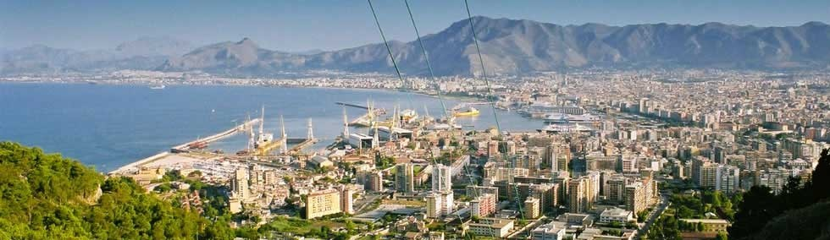
Looking forward welcoming you in Palermo, CIAS LA GUILLA is awaiting you!

YOUSTAR Team

