Participants Info Pack

‘Games For Social Entrepreneurship’
Training course

The international training course ‘GAMES FOR SE will be hosted in Larnaca by ‘Citizens in Power’ from
23.5.2022 (Monday). to 30.5.2022 (Monday).
(23. & 27. Are the travel dates)

24th May Tuesday (10 am, official start of the training) – 29th May Sunday (15 pm, finishes) 2022 Larnaca, Cyprus
Deadline to send participation forms is 27th of April 2022
Deadline to book tickets (Citizens in Power need to confirm the flights before participants proceed with the booking): 4th /May/2022

Each partner organization will be represented by 3 participants.

Contact details of the organizer: Rafaella Andreou
Email: cip-finance@outlook.com
Viber and whatsup: 00357 99186301

Organizer
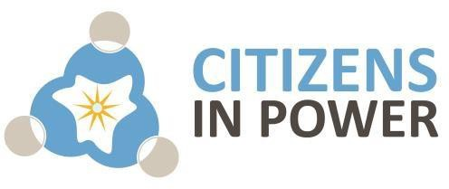

Partners
- C.I.P. Citizens in Power from Cyprus
- Permaculture Dalmatia from Croatia
- BE INTERNATIONAL from Czech Republic
- UDRUZENJE SVETLOST from Serbia
- Viaje a la Sostenibilidad from Spain
- Κέντρο Ενδυνάμωσης Νέων from Greece
- Geoclube – Associação Juvenil from Portugal
- Association of Ruse in help for society and young people in Bulgaria
- VCS SKOPJE from The Republic of North Macedonia
- Fondazione Stabat Onlus from Italy
- Seiklejate Vennaskond from Estonia

About the organizer

Citizens In Power (CIP) is an independent non-profit, non-governmental organization that addresses the needs and demands of people through their involvement in social and civic life, by simultaneously providing them innovative material and free trainings related with a variety of fields, such as education (including on-line education), inclusion, entrepreneurship and business, culture, labour market and lifelong learning.

CIP mainly aims at the development of education, entrepreneurship and lifelong learning in Cyprus and abroad. To achieve these targets CIP has an ongoing collaboration with the leading universities, schools, NGOs and research organizations in Cyprus for the development of projects, trainings and educational material.

CIP retains a valuable network of professional trainers and educational experts experienced in both formal and non-formal education. This particular network is considered competent to contribute to the implementation of activities related to the initiatives of CIP and its partners.
Our functions/ our vision CIP is primarily seeking to:
-expand contemporary methods of different levels of education, by developing both formal and non-formal methods of teaching;
-collaborate with the relevant stakeholders to promote research and creativity for the modernization of teaching;
-increase the employability of young people through entrepreneurship education, practical experience and lifelong learning by simultaneously aiming to reintegrate the
marginalized or disadvantaged groups such as migrants and refugees into the society in numerous ways and;
-support and train members of its local and international networks in numerous ways such as the exchange of information and good practices, through the sharing of experiences and ideas.

CIP has been is involved in 70 KA2 proposals and have delivered more than 20 Erasmus+ youth worker trainings in Cyprus.
www.citizensinpower.org

The Training Course

The EU commission stresses that there is a need to develop a more entrepreneurial culture, among EU citizens in general. In the ongoing years, the idea of Social Entrepreneurship has been on the ascent, with the EU particularly advancing it as an instrument to handle youth unemployment and social inflation and to accomplish sustainability. Through its capacity to prod collaboration between the public sector, civil society, private business and education sector, SE makes new business openings and offers solutions for profound social issues. Characteristic of this, are the 11 million specialists nowadays working in this sector in 2 million social enterprises (6% of EU business) that represent 10% of EU's GDP and profiting social groups, aside from proprietors and stakeholders. Additionally, social enterprises have proven more resilient to crises, while the survival rates of social start-ups are twice as high as conventional ones. The social economy and SE comes to battle exclusion and unemployment while individuals who may not really have explicit competences and skills can have the chance to find work or even go into business. However, the lack of knowledge and resources to kick-start these ambitions do not allow them to
progress. Subsequently, developing an innovative SE education with a European scope would address this issue in a transnational way, thus increasing the potential participation and activation of youth and adults in EU. A complex and multifaceted nature of teaching – learning requires a rich repertoire of teaching methods. The essence of modern understanding of methods is the evocation of action, development of thinking and creativity (Kruszewski 2005; Król 2007).

Coping with risk, persistence and critical thinking are ones of many skills that we can develop using available teaching methods, which are frequently still seen as unconventional. As indicated by several studies, play and creativity have been connected in multiple points of view, as play has been found to encourage knowledge capacity and divergent reasoning. Play has been a fundamental tool for learning, numerous educators around the globe have come to understand that games are problem-solving activities approached with a playful attitude. That’s why they engage and excite students, resulting in deeper learning and development of various skills when used for educational purposes. Competences acquired when playing didactic games, e.g. persistence, critical thinking or readiness to run risk, facilitate the development of entrepreneurial attitudes.

Didactic games used in the teaching process are met with growing interest and recognition at schools and in institutions. Learning with them has undisputable didactic merits in comparison to the traditional teaching model (Surdyk, 2009; Kapp, 2012). The competences acquired during didactic games, particularly in strategic and location-based games, facilitate the development of entrepreneurial attitudes.

The primary aim of the project is to support the professional development of youth workers and the development of a new innovative approach to youth work delivery, specifically, teaching social entrepreneurship through gamification and game based learning activities.

The main activity of the project is the Games 4 SE training for youth workers, that will provide the youth workers with knowledge, tools and skills necessary for providing young entrepreneurs and youth in general with much needed entrepreneurship skills, while focusing on social impact through business activities. The training course will provide youth workers with new innovative curricula, as well as with new digital and physical tools for delivering social entrepreneurship activities to youth. Participating in the training, youth workers will not only learn through play, but they will become the creators of their own teaching materials.

All learning activities are designed in accordance to the project’s objectives, respecting the main principles of the non-formal education and are in line with the general policies, objectives and priorities of the Erasmus+ programme. Additionally the project promotes social entrepreneurship, women entrepreneurship and sustainability.

Project objectives:
-To enhance youth workers' competences to support their motivation and capacity to implement innovative youth work as well as to improve their opportunities for employment
-To boost both youth workers’ soft skills and entrepreneurial skills by engaging them in gamified and game based activities on social entrepreneurship
-To provide youth workers with creative and innovative curricula as well as with new tools and methods for delivering social entrepreneurship education to their target group
-To increase capacity to trigger changes in terms of modernization of youth work through enhancement of international cooperation of the consortium

-To promote social entrepreneurship, women entrepreneurship and sustainable development

⸿ Working Methods and Language

WORKING METHODS
- The training will be based on non-formal education methods, encouraging active participation of young people involved.
- group work, ice breaking activities, group building,
- online quizes, observation of online content,
- discussion, case study, presentation, creation of online content, role playing, exchange of good practices,
- facilitation by trainers, site visit, input from experts,
- participating in an educational gamified activity
- peer to peer education, networking, e-learning, idea planning

WORKING LANGUAGE
English

⸿ Eligible Participants
- Youth workers
- Young people interested at the objectives of this project and they are willing to share what they will learn in their respective organizations

⸿ Travel and Finances

COVID-19 and travelling information!

Due to the COVID-19 pandemic there are specific travelling requirements for those arriving to Cyprus.
The countries of origin have been divided in color categories. See where your country is here: https://cyprusflightpass.gov.cy/en/country-categories

For those who have not been vaccinated rapid test might be needed to enter Cyprus. Participants are responsible to find the latest info about the enty requirements to Cyprus and the entry requirements for their return back home. The covid-19 measures during summer are usually much less.

Useful site: https://reopen.europa.eu/el

All participants should make a self-test before arriving for the safety of all participants. Those who are diagnosed with covid before arriving to Cyprus they should send a proof to CIP in order for us to claim their travel expenses under the Force Majeure in the final report ( reimbursement of ‘Force Majeure’ will be made after the approval of the final report, expected November 2022) CIP has the right to make self-test to the participants every day if its needed on the expense of CIP ( extra focus will be given to those with symptoms)

All travelers must apply for CYPRUS FLIGHT PASS 48 hours before the commencement of your travel from the Country of Origin to the Republic of Cyprus (either direct flight or via intermediate Countries) here: https://cyprusflightpass.gov.cy/

This is subject to change till the time of the training ( Flight pass might be lifted)

More about travelling…

Travel expenses are a heavy burden on the budget of this project. Participants are therefore required to arrange their journeys in the most economical manner possible. In order to find the most economictickets we advise you to visit www.skyscanner.net Tips for cheap flights http://www.farecompare.com/travel-advice/tips-from-air-travel- insiders/#/
-Larnaca International Airport - has the biggest number of airlines and connections. Closest to the venue, cheap flights by Blue air, Wizzair, Aegean airlines and others. (Prefer Larnaca’s Airport because is close to the venue)
-Paphos Airport (second airport of Cyprus, this should be your second option). Cheap flights by Ryanair, Easy jet and others

Please bear in mind that according to the guidelines of our National Agency the travel dates can be plus or minus 2 days (the cost for the extra travel dates is not covered, for example accommodation, food and transportation). You can either a) arrive one day earlier and leave one day later or b)arrive two days earlier and leave on time c)or arrive

on time and leave 2 days later d) or arrive on time and leave one day later or e) arrive one day earlier and leave on time. All these options will be accepted only if they have the same or lower value with the actual travel dates of the training course (start day and last day of the training).
Irrespective of the means of the transport used, participants will be reimbursed on the basis of the least expensive route between their place of residence and the town in which the course is held.

Please don’t book any tickets before receiving our written confirmation. Travel agencies (such as BlueSky, Gotogate, etc are not acceptable for bookings. Before any bookings please contact CIP first on cip-finance@outlook.com

FUNDING CONDITIONS:

ERAMSUS+ Programme, Key Action 1
100% of accommodation and activity costs are covered by the programme
The international travel costs are covered according to the rules of ERAMUS+ (distance band calculator, 100-499 km = 180 euro, 500-1999 km = 275 euro, 2000-
2999 km = 360 euro, 3000-3999 km = 530 euro, 4000-7999 km =
820 euro).

Reimbursement will be provided to the participants who are involved in all the activities of the training, participants can request exception for some of the activities, which can be approved only when is an urgent need and with the provision of evidence.
Croatia | 275
Spain | 360
Portugal | 530
Macedonia | 275
Estonia | 360
Italy | 360
Czech Republic | 275
Serbia | 275
Bulgaria | 275
Greece | 275

Please note: eligible airports for landing are the international airport of Larnaca and in special cases Paphos (second option)

Visa
In case you need a visa to come to Cyprus. Please inform the organizers first and then have a look at this:
http://www.cyprusvisa.eu
After you receive our confirmation for booking your tickets and you’re not sure how
to book your flight, feel free to ask us, we will be happy to helpyou.

Documents/actions needed to complete your reimbursement:
In order for the Citizens in Power to precede to your travel reimbursement you must present when requested the following documents:
- Invoice or copy of credit card slip of the travel payments.
- Boarding pass (please resist throwing them away in the nearest bin after you leave the plane – you will NOT be refunded without them).
- Travel reimbursement form (which you should collect in the reception on your arrival).
- Relevant tickets or a copy (plane, bus, etc).

- NOTE that NO electronic tickets will be reimbursed if the original invoice is not provided. The reimbursement will be done via bank transfer within 30 days, after the receipt of all travel documents including boarding passes.
- Travel refund to the participants will be paid by bank transfer to organizational account/personal account for the whole group after all travel documents will be received by the Citizens in Power.
- Before the execution of the reimbursement, participants need to fill a questionnaire that is generated from the mobility tool (organizers will inform you accordingly).

Without the originals, we can’t reimburse the travel costs. Please print out all your flights tickets, even if you sent them to us before, we need them in paper for the reimbursement!!!!!

⸿ Accommodation

ABOUT THE VENUE
The venue of the training course is Hotel Cactus in Larnaca (6-8 Tyrimou Street)., near McKenzy area, very close to the airport of Larnaca. MacKenzy is actually a beach full of life, café and restaurants, especially the weekends. More information about the city of Larnaca, here http://www.Larnaca.org.cy/index.php/en/page/home#.Vo4zWfl95D9

YOUR ROOM
The rooms are triple due to high seasonality, fully equipped with everything you may need. Towels are changed every 2-3 days, bed sheets every 3 days. The rooms are very close to the training venue. We will combine people from different countries in the same room so as all the participants to have the opportunity to get to know each other.

What to bring:

Please bring any medicine you might need. We don’t have all the medicines you might need in Cyprus (brand, ingredients etc) also the medicines in Cyprus are very expensive in comparison to other EU countries.

LAPTOP
You are strongly advised to bring your laptop (if you have one) because we will work on freeware and programs that you can use for dissemination of your activities, project management etc. Please try to bring one laptop per country to use it some of the sessions.

PREPARE FOR THE TRAINING
For some of the activities we will need you to prepare from home.
- Use qrinfopoint.com (free QR code generator) to create a QR code from your childhood photo. Upload the photo into the generator provided on the website. When the generator generates the code, send the code to the trainer via e-mail
- You will be asked to share and discuss the informations about the successful social businesses in your country. Research online and make notes.
- You will be asked to share and discuss the informations about funding opportunities in your countries. How are NGOs, Small business’ and other non- governmental organizations in your country funding themselves? Research online and prepare notes.

INTERNET ACCESS
We will have free internet access in the plenary room and in the lobby area but not in the rooms. You can connect with your laptops. There is WI-FI in most areas of the hotel.

Information regarding extra Facilities
The hotel offer free wi-fi in the communal areas.
If you want to have internet in your room ( per room), the cost is as follows

€4 per day
€8 for 3 days or
€16/ for a week
The Hotel can install you a fridge in tour room for 2 Euros per day.
Please contact in advance the hotel if you want to make a booking for your extra stay

in Cyprus. Prefer to arrange your stay with other participants in double or triple rooms because single rooms are very expensive.

Few pictures of Larnaca
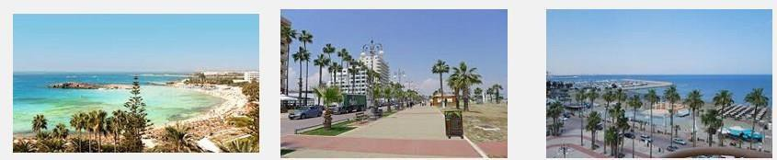
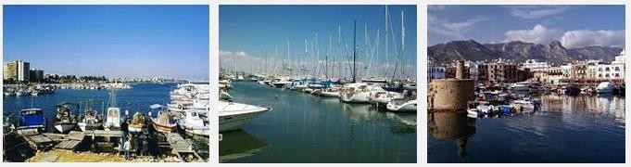

Few pictures of the Hotel
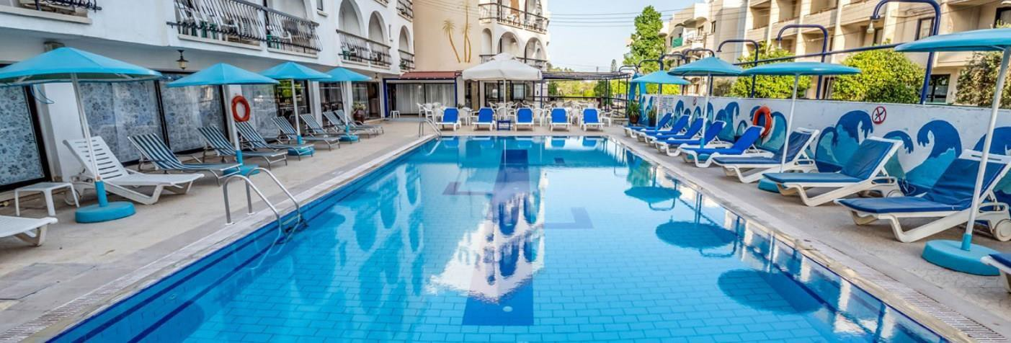
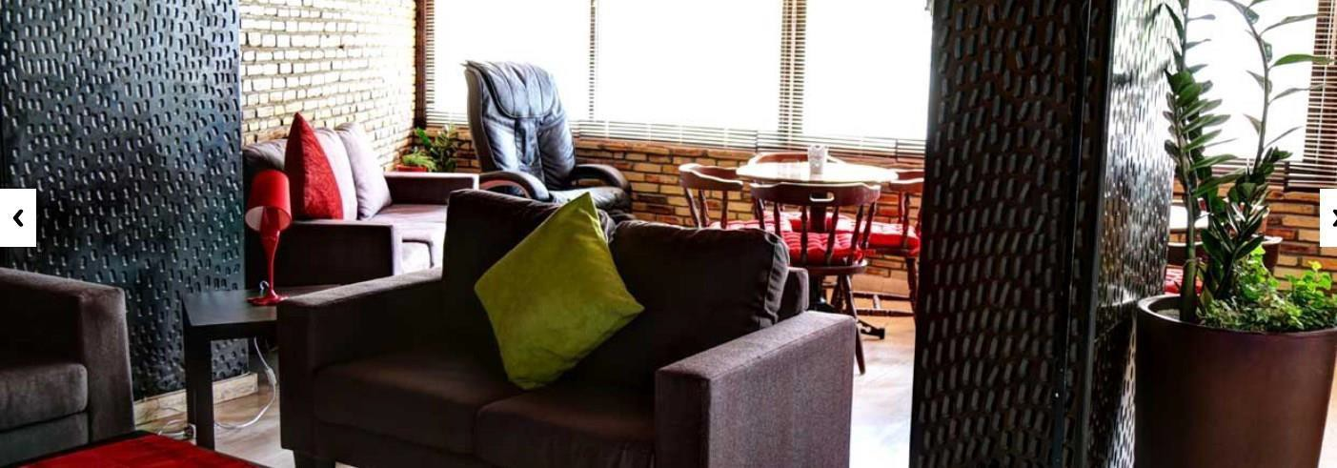

Contact details CACTUS HOTEL
Email: cactushotel@cytanet.com.cy

Tel: 00357 24 627400

Tyrimou Street ,P.O. BOX 40188, 6301 Larnaca
website: http://cactushotelcyprus.com/Home

SAFETY AND INSURANCE

Travel and accident insurance is a responsibility of the participants. You are advised to buy a regular travel and/ or accident insurance during your travel and your whole stay in Cyprus.
Please do not forget to arrange your travel insurance including the responsibility insurance (in case of causing third party damage). Health insurance is not provided by the organizers, the citizens of the European Union are entitled to the European Health Card. All the participants are strongly advised to bring with them the European Health Card, not to be forced, in case of an emergency, to pay the costs of health care in Cyprus.

Participation fee/ cost

Food and accommodation is FREE. There is a participation fee of 40 euros which the participants are required to pay in cash during the TC. Please, pay special attention to this point as we will not be able to keep this amount from the money you will get back for your travel expenses.

Food
The food will be prepared by the hotel.
If you are a vegetarian or you have any allergy problems, please inform us as soon as possible.

⸿ How to get to Larnaca from Paphos airport

Please check the detailed schedule at http://www.kapnosairportshuttle.com/ and then book your tickets. In case you miss the bus, you will not be charged. The payment is made in Cyprus at Kapnos station. The booking guarantees you a sit in the bus.

You can take either Travel Express from 0800 – 14:00 (sometimes from 06:00 to 1700) (you have to book in advance http://www.travelexpress.com.cy/ ) or Kapnos Airport Shuttle (you better book in advance).

Please check the prices and choose the cheapest one. The travel express will bring you to the venue directly and with Kapnos you will have to take another bus from the central station in Larnaca to the venue (Cactus Hotel in 6-8 Tyrimou Street).The nearest bus station is Oum Charam with bus 425, http://www.cyprusbybus.com/busesmap.aspx . Remember to ask people or the bus driver for help, Larnaca is a small place, everyone knows the hotel and the bus drivers are very friendly. If you arrive or depart during the programme period, one of our volunteers will pick you from Kapanos shuttle in Larnaca, in this case you will not need to take a second bus.
So from Paphos International Airport one of the options is to take KAPNOS Airport Shuttle to Larnaca. Before exiting the airport, search for the Airport Shuttle KAPNOS (meaning – in Greek- and moving like SMOKE!) and buy your ticket to Larnaca, and then search for your bus outside the airport. The ticket will cost around 15 Euros from Paphos (oneway ticket, the amount for the tickets is already included in the given budget, keep The receipt!), and the 80-90-minute-long trip.

Kapnos telephone number: +357 24008718.

Please note that taxi service is not reimbursed in any case!

⸿ How to get to Larnaca from Larnacas airport

For the first and the last day of the TC we most probably (upon availability of our members) pick you from the airport (first day) or the hotel (last day) using the private cars of our members.

You will need to inform us in advance by email (cip-finance@outlook.com) about any changes in your arrival time. When you arrive in Larnaca we will arrange someone to pick you up from the airport.

From Larnaca airport you can also take the bus number 425 http://www.cyprusbybus.com/RouteDetails.aspx?id=106 that has a stop very near to the hotel. The nearest bus station is Oum Charam with bus 425, http://www.cyprusbybus.com/busesmap.aspx

Remember to ask, Larnaca is a small place, everyone knows the hotel and the bus drivers are very friendly for sure other busses pass very near the hotel.

Please note that participants who arrive or depart at dates that are different from the schedule, they have to make their own arrangement to and from the airport at their cost. For example the training starts (arrival day) on 20 Jul, and participants arrive on 19 Jul, he/she is considered out of schedule. Also they have to cover the cost for the accommodation for the extra days.
⸿ Some Practicalities
The price of products and services in Cyprus varies depending on the season and the location.
Below is an indicative list in Euro:
- A single bus ticket costs around €1.5
- Water (0,5l) from €0.50 in a local kiosk
- Shower gel from €2.50
- Small juice pack (0,20L) from €0.50
- Toothpaste from €2.50
- Phone card with €5 of credit from €5.00
- Chocolate from €0.70
- Fast food from €4.00-7.00
- A glass of beer costs between €3.50 and €5.00
- A ticket to the cinema costs around €7.00 for adults and €5.00 for children
- Dinner at a local tavern (meze, including beer or cold drink) costs around
€20.00

⸿ Money and Currency
The currency of the Republic of Cyprus is the Euro. There are seven denominations in Euro banknotes: 5, 10, 20, 50, 100, 200 and 500 euro. They all have different color and size, the higher the denomination, the bigger the size. One euro is divided into 100 cent. There are eight euro coins: 1, 2, 5, 10, 20 and 50 cent, €1 and €2. The designs on one side of the coins are common to all the countries of the euro area, while the other side reflects national identities. All euro coins can be used in all euro area countries, irrespective of their national side.

⸿ Weather Conditions
Cyprus enjoys an intense Mediterranean climate of hot dry summers starting in mid- May and lasting until mid-September and rainy, quite mild winters from November to

mid-March. Spring and autumn are effectively short intervals in between, characterized by smooth weather. With almost year-round clear skies and sunshine, daylight length ranges from 9.8 hours in December to 14.5 hours in June.
And for a very accurate ten-day weather forecast by CNN (that will also help you organize your clothing and suitcase accordingly)

⸿ What to bring
- Summer Clothes.
- A hat, sunglasses and sunscreen
- Medicines if you need.
- Musical instruments and other stuff – we will have free time to enjoy together.
- Alarm clock.
- Athletic shoes.
- Motivation and good mood.
- Please bring your plug. We use UK plugs, if you forget the hotel will provide you one with 3 Euro deposit.
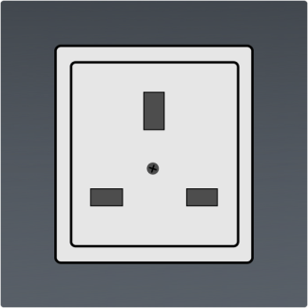
We will try to hold some of our activities outdoors, so bring comfortable clothes and shoes. Do not forget your swimming suit and equipment if you want to try the pool or the sea. Keep in mind that the hotel is near the beach. You have to bring your own beach towel.

Bring also:

For the intercultural night:
Local food and/or drinks. There is a refrigerator in the hotel.

For the International Night:
Information material about your country, your organisation, culture and general aspects of the culture that are typical characteristic of the area you belong to. It will be great if you could bring posters, brochures and other small things. Please bring short video or power point presentation of your organisation and/ or country.

⸿ Some facts about Cyprus
Floating on the waters of the Mediterranean, but pointing longingly towards the shores

of Syria, Turkey and Lebanon, Cyprus is an odd mixture. It is a kaleidoscopic blend: its cultural influences are dominated by Western Europe, but its geographic proximity to Asia and Africa gives it more than just a hint of the East. Long coveted by mainland Greece and Turkey, this small island has its own definite and beguiling character.
Cyprus is the island for all seasons, the island of good weather, good mood and loads of sunshine! The people of Cyprus are warm – hearted, hospitable and kind, people who love to go out and who appreciate good company and good food. In fact, most of the social outings and relationships revolve around food! And that’s food that is coming in a lot of variety and large quantities for massive stomachs!
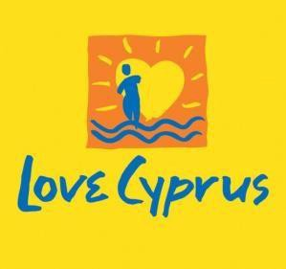
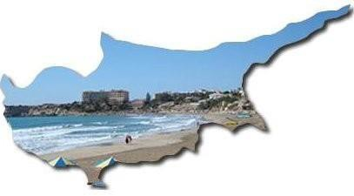
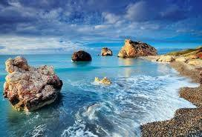

While in Cyprus it’s a must that you try:
Cypriot meze (appetizers akin to Spanish tapas) are an art form, and some restaurant serves nothing but just that! Meze are available in a meat variety or fish variety but quite often come as a mixed batch, which is rather pleasing.
Sheftalia which is a kind of sausage without skin. The filling of sheftalia is made of ground pork or lamb shoulder and leg. It is mixed with fine chopped onions and parsley and seasoned with salt and pepper. Instead of sausage casing it uses caulk fat, the membrane that covers the stomach of a lamb or pig, to wrap the ingredients. In words it may not sound so good but in the mouth it is simply yummy yummy!!!
Halloumi is a uniquely Cypriot cheese, made from a mix of cow's and sheep's milk. Hard and salty when raw, it mellows and softens when cooked and is hence often served grilled.
Taramosalata is traditionally made out of taramas, the salted roe of the cod or carp. The roe is either mixed with bread crumbs or mashed potatoes. Parsley, onion, lemon juice, olive oil and vinegar are added and it is seasoned with salt and pepper.

And of course this is just a short list. There are plenty more tastes and dishes to try! Another important thing about Cyprus is the social life of Cypriots who normally spend their free time (mornings, afternoons, evenings, we simply don’t mind) going for coffee in several coffee shops around the city, that stay open until around one o’clock at night! Coffee is quite popular even at 10 or 11 pm and what is also very popular is the special “frappe”, which seems to be something like a Greek coffee invention. Later,

during the evenings people hit the clubs at around 12:30 with the party lasting until the early hours of the morning, when again they try to get rid of the hangover with more food at local fast food restaurants.
For more information visit click HERE.

Please take note of the following conditions that will apply if you are selected to take part in the training

⸿ - Commit to participate in the whole process, including: to prepare carefully for the training course; to do all remote preparation work the team will ask for; to take part in the full duration of the TC; to participate in the whole evaluation process.

⸿ Each participant who attends the aforementioned training course is responsible to obtain travel and accident insurance (including third party damage) for their stay in Cyprus.

⸿ Health insurance is not provided by C.I.P. Citizens in Power. The citizens of the European Union are entitled to the European Health Card. You have been informed to proceed with all the necessary arrangements and obtain a European Health Card. Please confirm as soon as you get yours. Otherwise, in case of an emergency, you will have to pay the costs of health care in Cyprus.

⸿ - Be aware that obtaining a health and a full travel insurance is your own responsibility and at your own expenses. Understand that the information you provided on your special needs does not remove your own personal responsibility for ensuring your own health.

⸿ - Authorise National Agencies and the European Commission to publish, in whatever form and by whatever medium, including the Internet, my correspondence address, information about my organisation and work and pictures taken at the seminar.

⸿ -Respect the deadline for booking your tickets to Cyprus.

⸿ -There is a participation fee of 40 Euros.

⸿ -Participants per country will create one dissemination report related to the training that might be published in social media (size: one A4 page max)

Useful telephone numbers

- Meneloas 00357 99987565 Cactus hotel 00357 24 627400 Angelos 00357 96619661
- 112 is the common emergency telephone number that can be dialed free of charge from any fixed or mobile telephone in order to reach emergency services (ambulance, fire and rescue, police) in numerous European Countries including Cyprus

⸿ Some Phrases in Greek

Hello! – Yia sou! (for one person) Yia sas! (for more than one person) Good morning – Kalimera
Good afternoon – Kalispera Good night – Kalinihta Excuse me – Siggnomi Please – Sas parakalo Thank you – Efharisto
Help – Voithia Beer – Mbira Wine – Krasi Water – Nero Food – Fayito Money – Lefta
Restaurant – Estiatorio
Toilet – Tualetta
Bus station – Stasi Leoforiou
How much does it cost? – Poso kostizi?
How can I go...? – Pos mboro na pao…?
Where is the bus station? – Pou ine i stasi leoforion?
One beer, please – Mia mbira, parakalo
I like you – Maresis
I am from Cyprus– Ime apo tin Kipro
I am from Bulgaria – Ime apo ti Voulgaria
I am from Italy– Ime apo tin Italia
I am from Latvia– Ime apo ti Lettonia
I am from Poland – Ime apo tin Polonia
I am from Romania – Ime apo tin Roumania
I am from Greece – Ime apo tin Ellada I am from Spain– Ime apo tin Ispania I am from Malta– Ime apo ti Malta
Where is the toilet? – Pou ine i tualetta?
You are very kind – Ise poli evgenikos (male) Ise poli evgeniki (female)

I want... – Thelo
I don‘t eat meat – Den troo kreas
How are you? – Pos ise?
My name is.. – Me lene
Can you give me Mboris na mu dosis…
It was delicious – Itan pentanostimo

