Info Pack

This project is financially supported by the European Commission through the Erasmus+ Programme

Advanced Planning Visit
5th – 7th August 2022
Struga, N. Macedonia

Youth Exchange

29.08.2022-05.09.2022

(Arrival on 29th August before 4 pm,

Departure on 5th September after 12 pm)

Venue Krushevo, N. Macedonia

Inclusive Art for Green Europe

APV’s objectives
The objectives of the Advanced Planning Visit are to bring together the partner organisations through their representatives (project coordinators or group leaders for the youth exchange) for the purpose of finalizing the practicalities with regard to the youth exchange and defining the work programme based on their participants and the set objectives.
Participants in the APV:
1 representative per partner organisation – the group leader involved in the youth exchange or the project coordinator or other key staff involved in the project.

The objectives of the YOUTH EXCHANGE
The objectives of the youth exchange are to raise awareness about the causes and effects of climate change, discuss good practices and potential solutions to come closer to carbon-neutrality and zero waste economy while promoting the inclusion of vulnerable groups, oftentimes the most at risk and under threat when it comes to climate change’s consequences and impact. In addition, the aim is to support creative expression and innovation in young people as a means to contribute to raising awareness through powerful messages and finding applicable solutions.
Participants in the youth exchange:
25 young people from N. Macedonia, Turkey, Croatia, Serbia, Estonia. Each country will send young people aged 18-30 years old for the participants and 18+ for the group leaders with no upper age limit.

* N. Macedonia – 4 participants +1 group leader

* Serbia – 4 participants +1 group leader

* Croatia – 4 participants +1 group leader

* Estonia – 4 participants +1 group leader

* Turkey – 4 participants +1 group leader

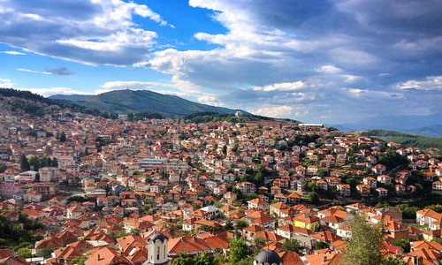

Financial Conditions:

• Accommodation, food, and materials during the activity days are fully covered by the project.

• Travel costs for the activity will be reimbursed when invoices, e-tickets, boarding passes, and other tickets are delivered to the host NGO according to Erasmus + rules.

Distance band
100-499 km 180€
500-1999 km 275€
2000-2999 km 360€

Do not forget to take with you:

- Personal hygienic products,

- House shoes,

- Comfy clothes according to the weather,

- Medicines according to your health and needs,

- Food and national specialties for the international evening.

Accommodation:

For this Youth Exchange, the participants will be accommodated in Vila Gora-Krusevo.

- Rooms with 2-3 beds with their own bathroom (the distribution in the rooms being made on the basis of sex).

- The structure has internet access, an activity room, and a restaurant that provides a full board.

- Bedsheets are provided - Accommodation, food, and materials during activity, are fully covered by the project

